1. [Practice] Matrix Multiplication – Fixed

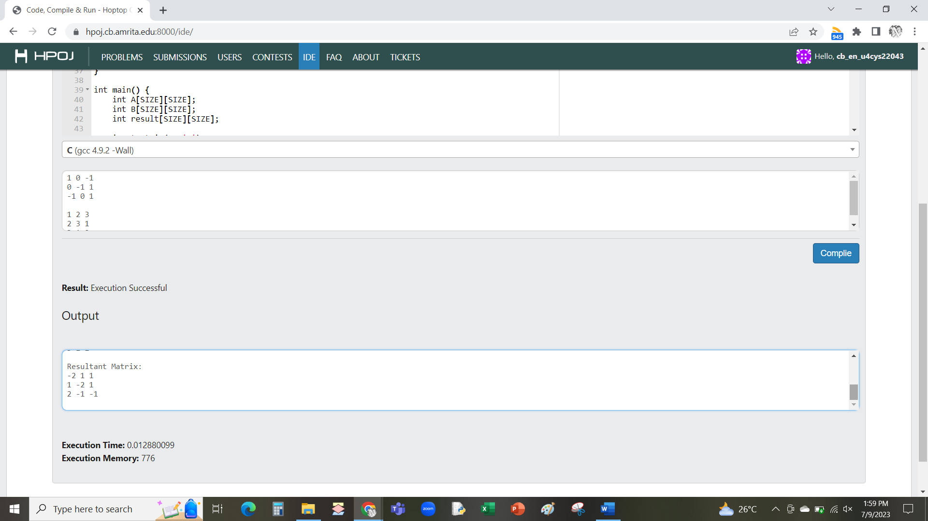

1. [Practice] Matrix Multiplication – Variable

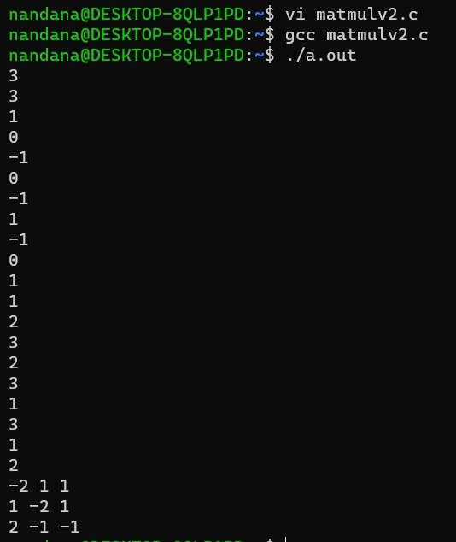

1. [Practice] Pattern - \* Half Pyramid

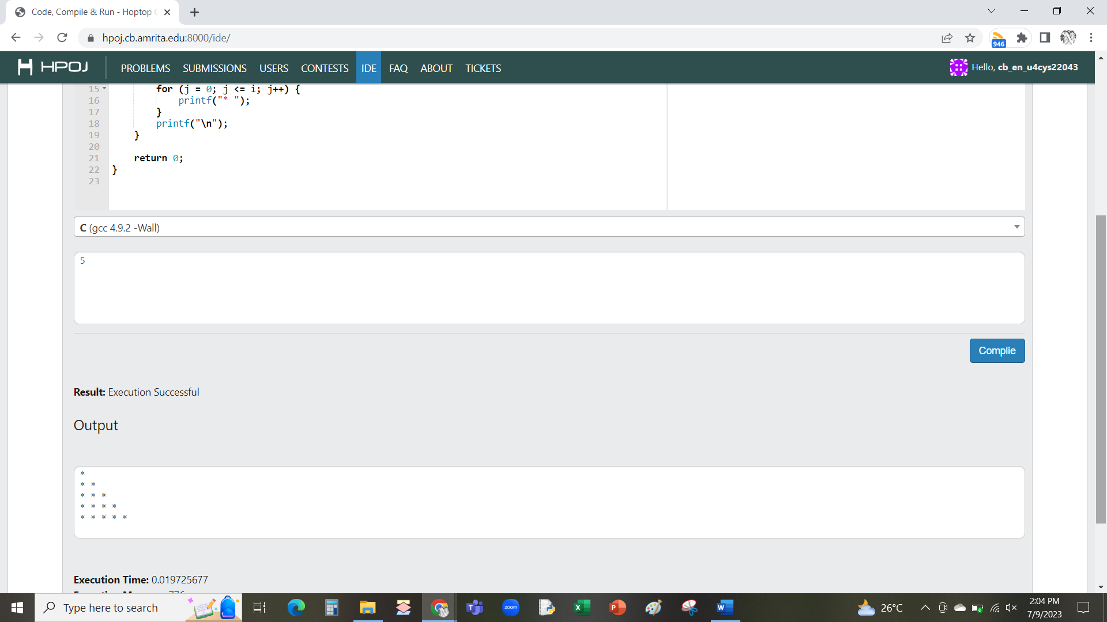

1. [Practice] Pattern - \* Full Pyramid

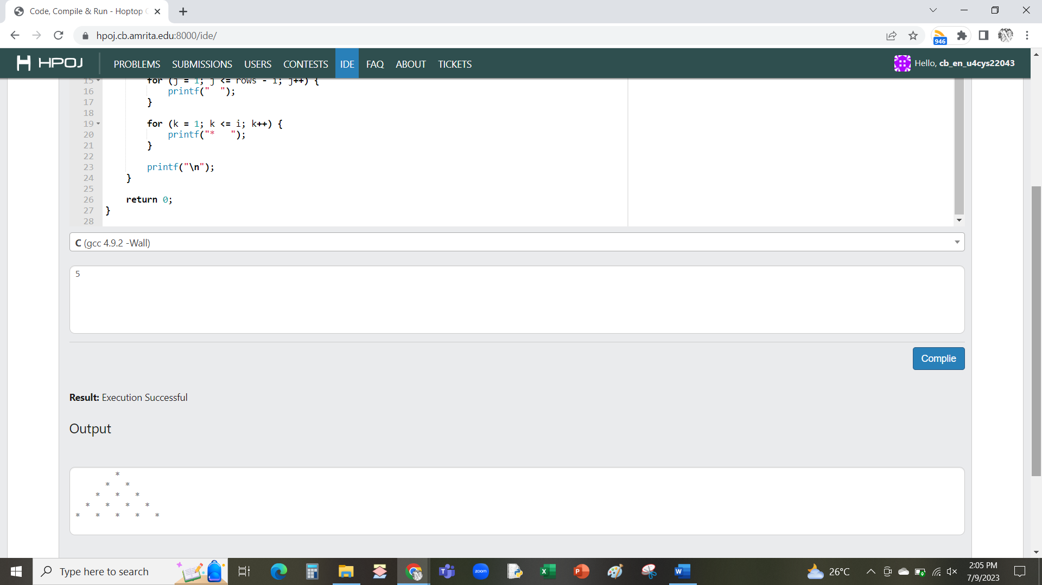

1. [Quiz 1] Palindromic Pattern Half Pyramid

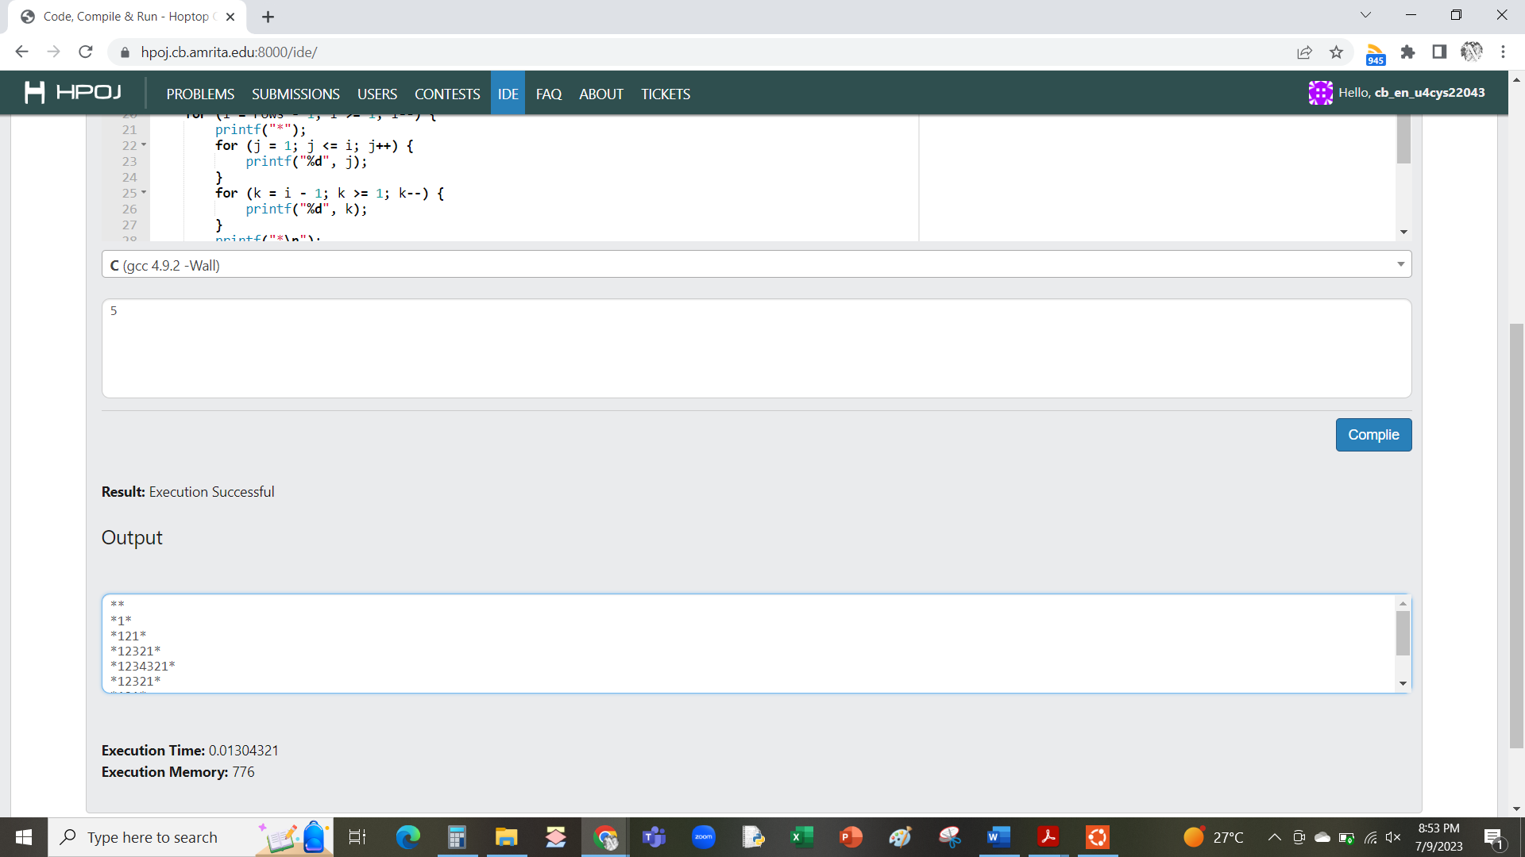

1. [Quiz 1] Palindrome Check

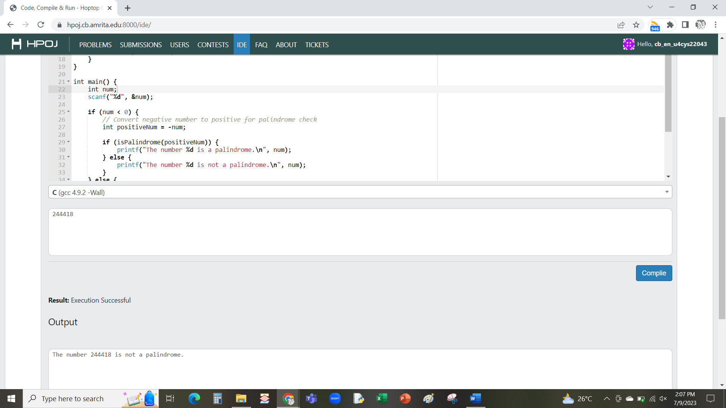

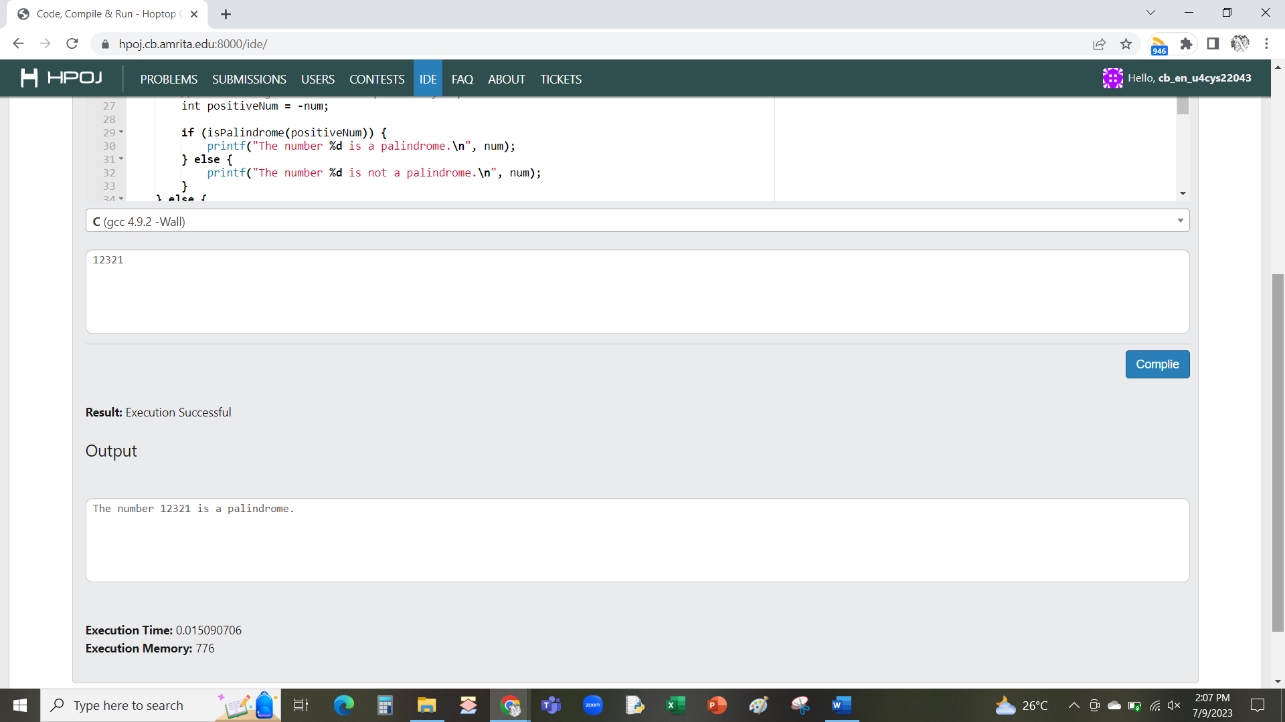

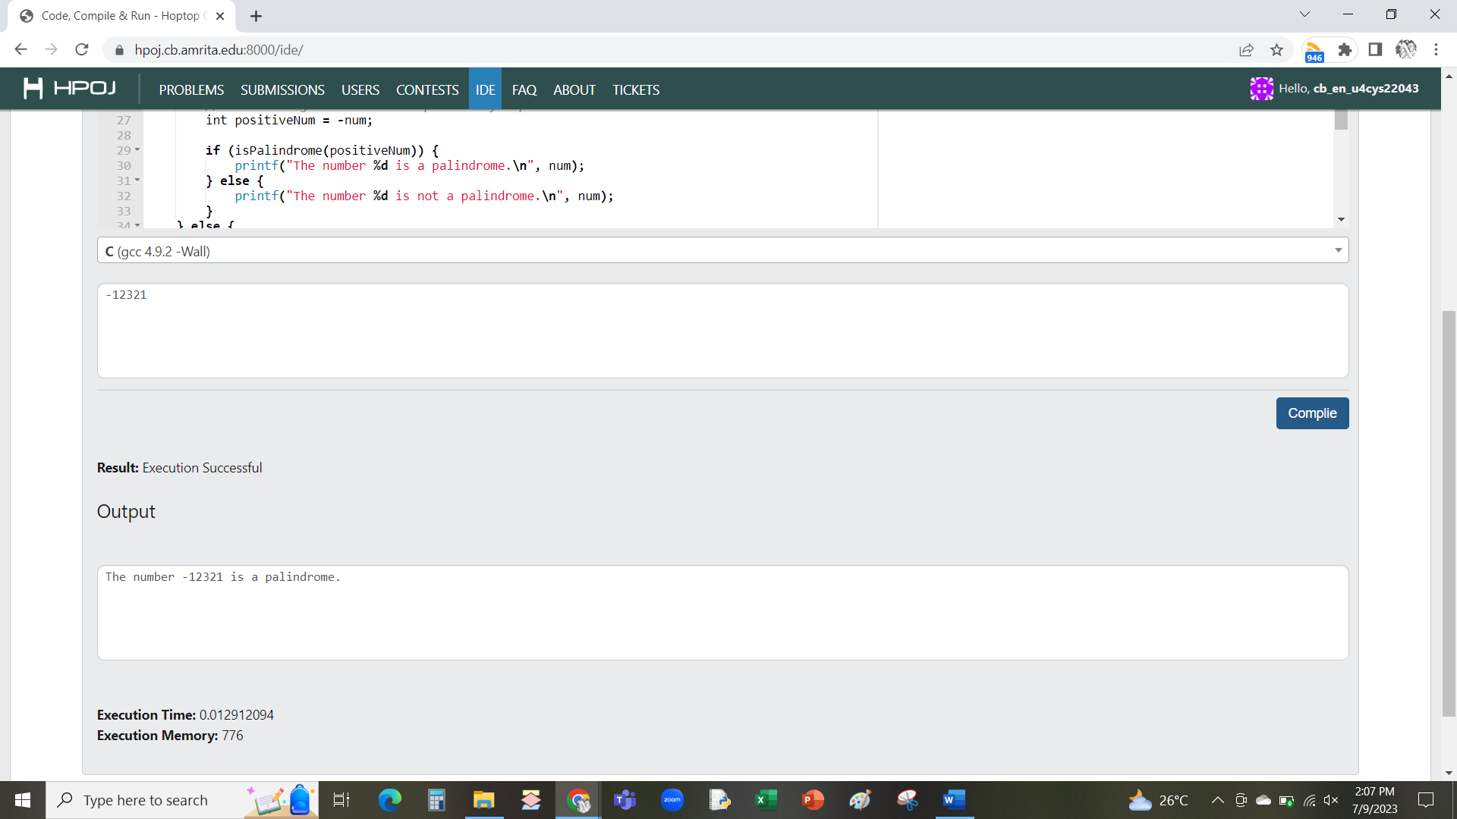

1. [Practice] Addition and Subtraction of Complex Numbers using Structure

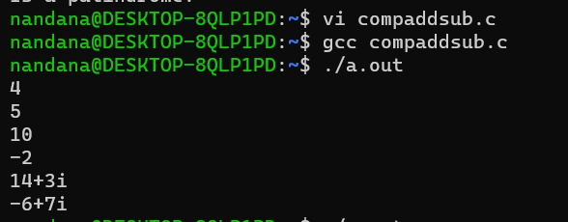

1. 20CYS181 - Periodicals 1: Calculate Electricity Consumption

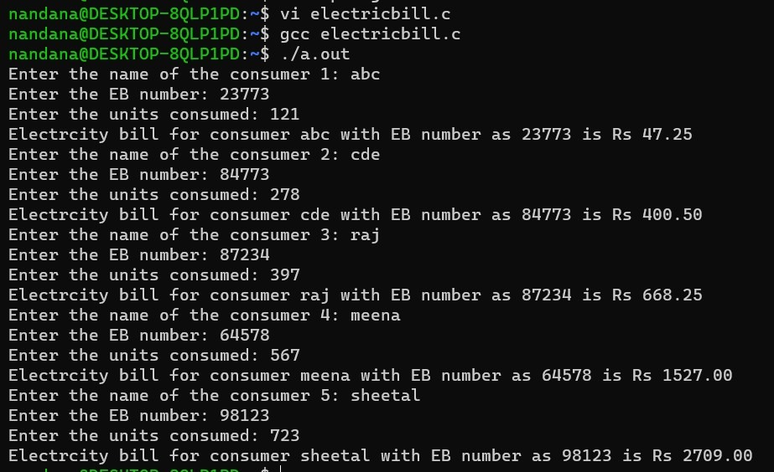

1. 20CYS181 - Periodicals 1: Number Diamond Pattern

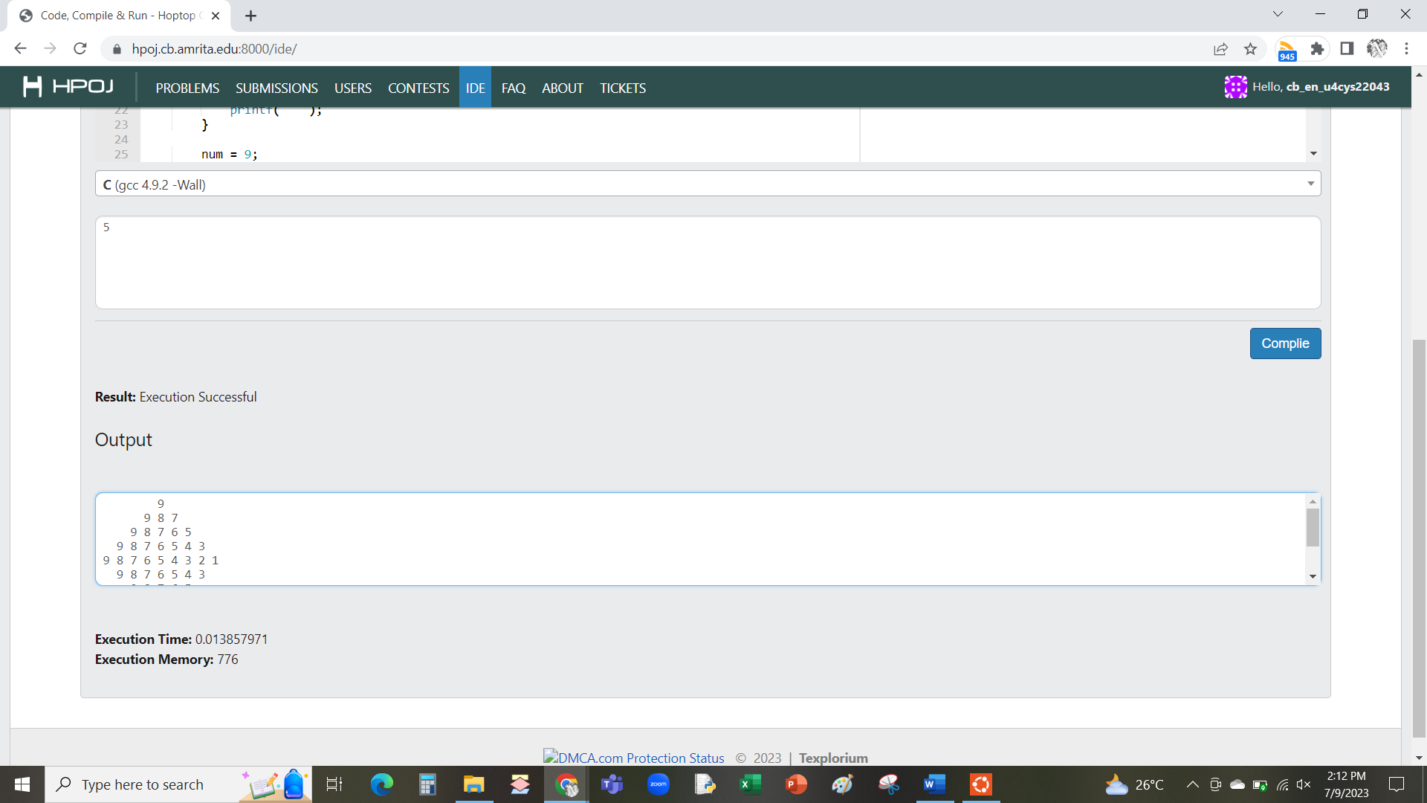

1. 20CYS181 - Periodicals 1: Alphabet Hourglass Pattern

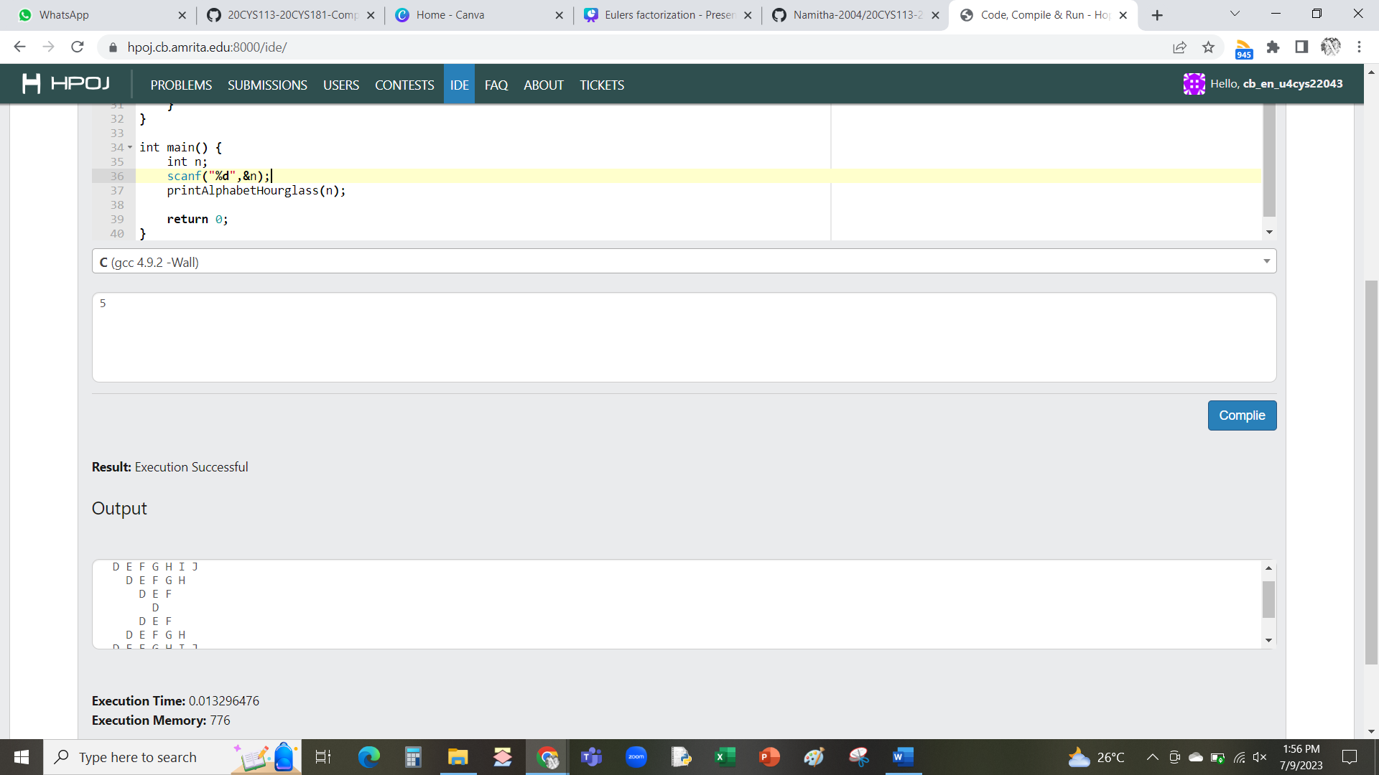

1. [Periodicals 2] Simple Student Management System

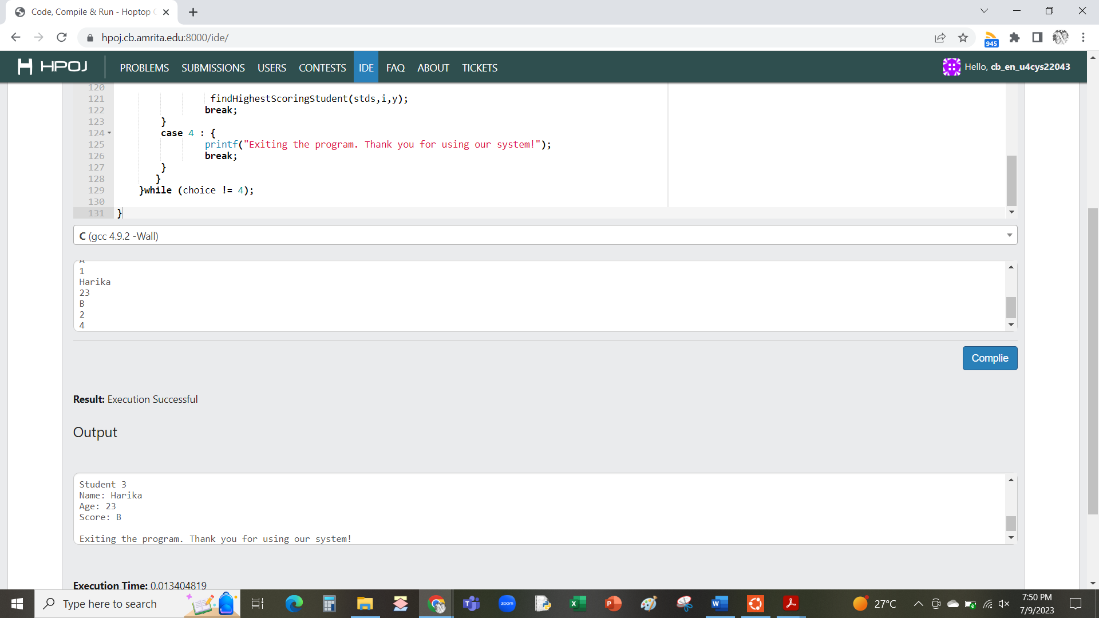

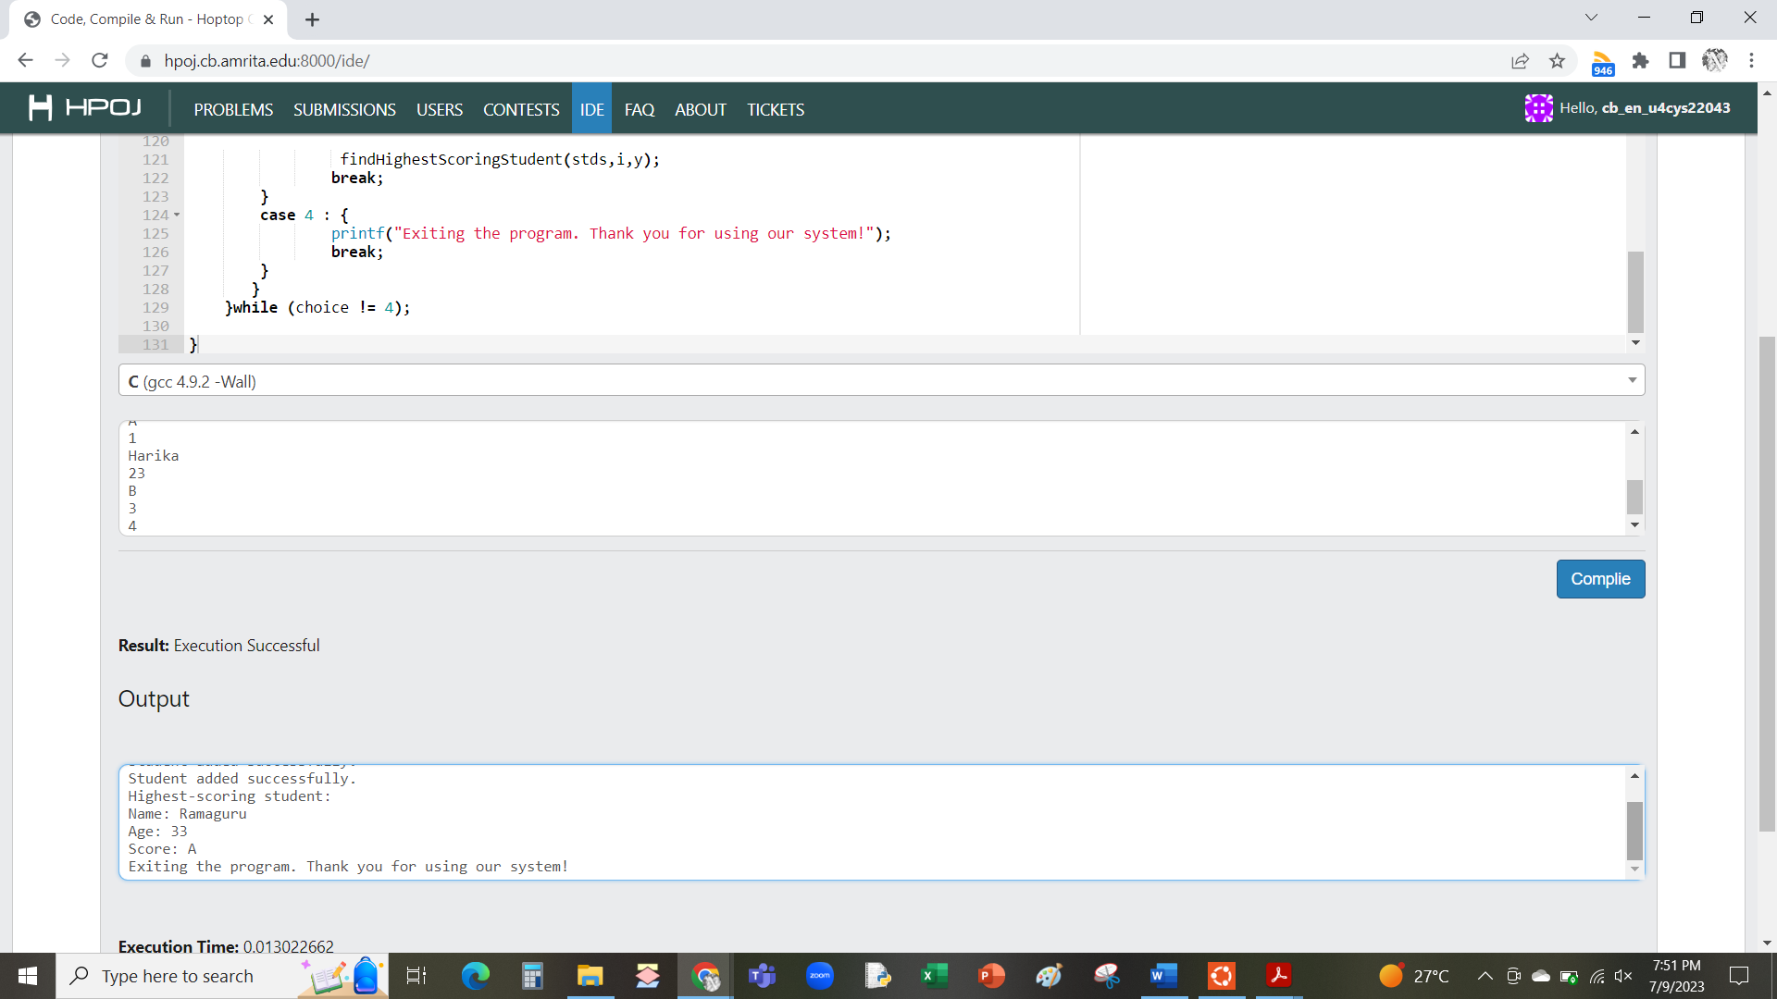

1. [Practice][Functions] Generate all the prime numbers between two given numbers

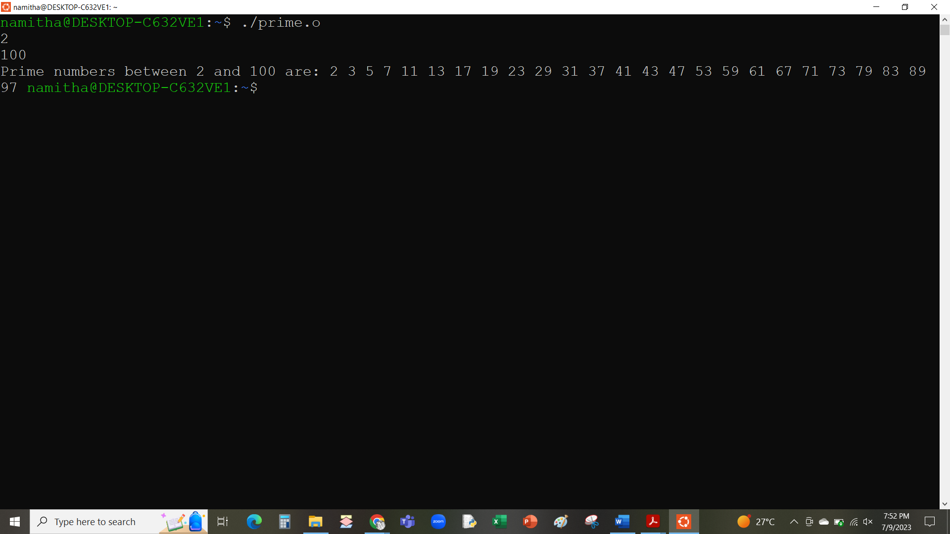

1. [Practice][Functions] Convert Decimal to Binary, Octal and Hexadecimal

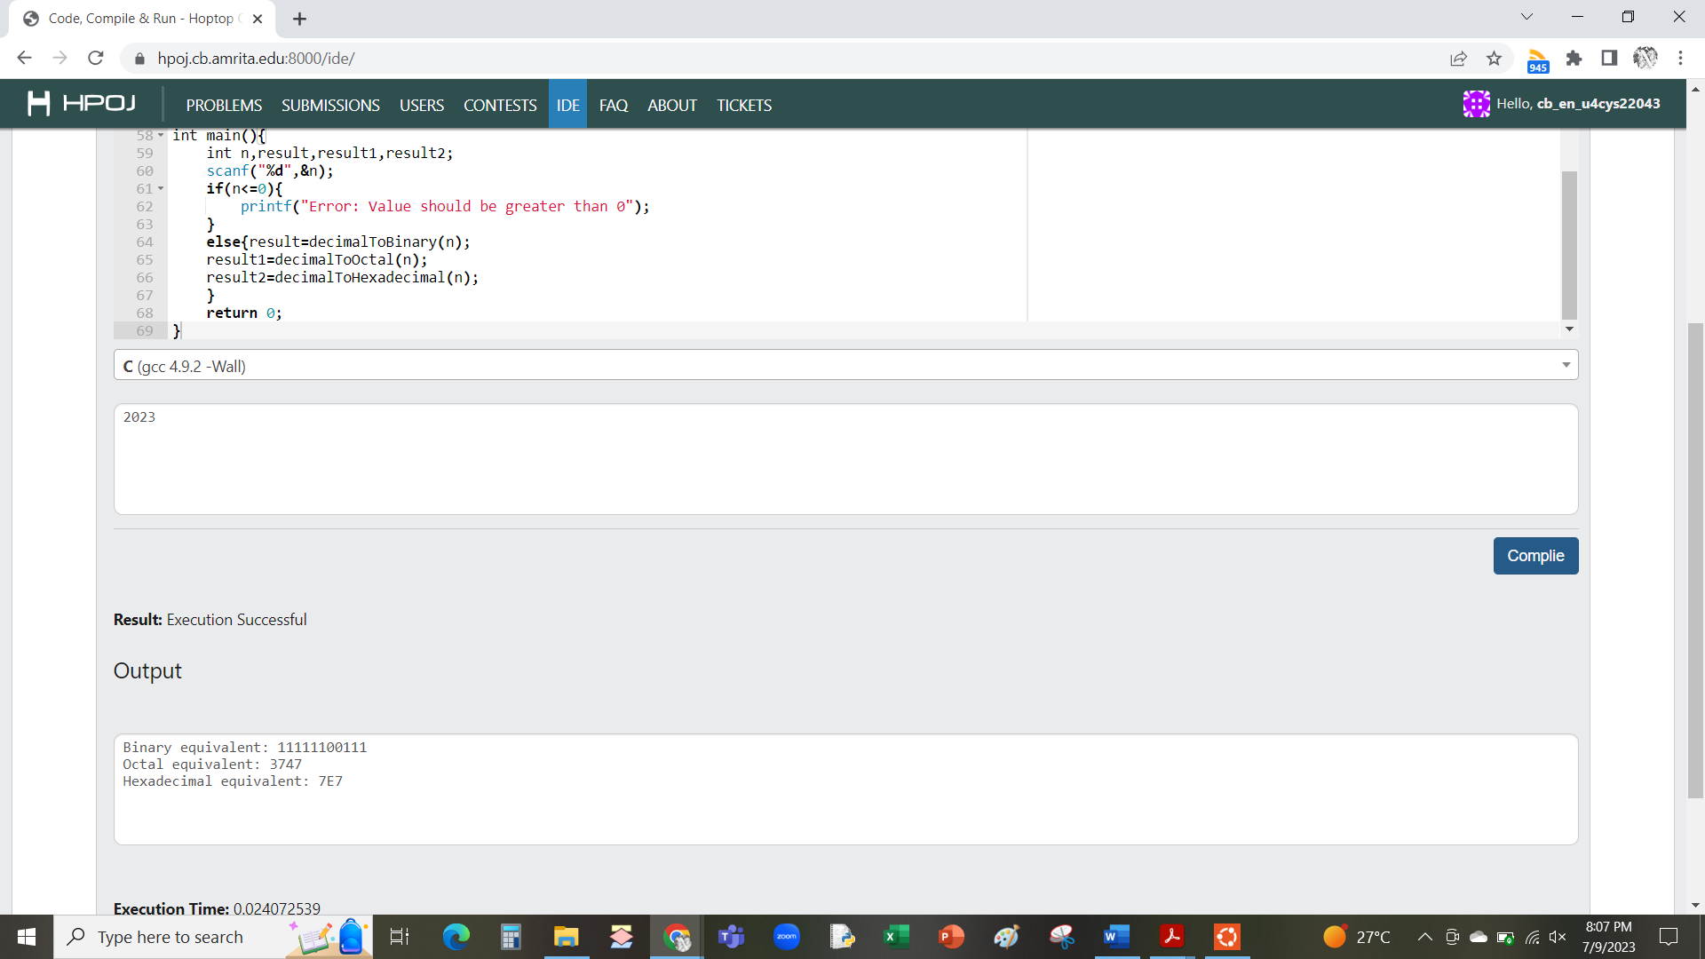

1. [Practice] Calculate Area - Structs, Unions, and Enums

